# CPT_Logo_Manual.jpg Getting Started with SharePoint 2010

**Lab Time**: 45 minutes

**Lab Overview:** In this lab you will interact with SharePoint 2010 lists. You will learn to identify the metadata included with various list s and the best application of each list template. You will also perform the task of choosing an appropriate view of a populated list. Lastly you will populate a list with items and then manage those items by editing and deleting them.

## Exercise 1: Identifying Lists and Metadata as Readers and Contributors

In this exercise you will examine existing lists in a SharePoint 2010 site and determine which list is appropriate for specific business data. This is a question and answer based exercise that requires you to log onto an existing SharePoint 2010 site to answer the questions.

1. Log into your site collection using the account **Michael Sullivan**. This user does have access to the site collection and therefore will be permitted access. Michael is only a visitor of this site and therefore only has read rights on the site collection.
2. Using Internet Explorer, browse to the URL of the SharePoint site collection you were provided to use when working on the hands on labs in this course.
3. When prompted to login, enter [[AD-DOMAIN]]\michael in the **User Name** field and click **OK**. Use the password specified in the Hands-On Lab Overview document provided in the student manual.

**Note**: If you are not prompted to login & if you are logged in as another user use the Welcome Menu to logout and login as a different user.

1. Use the Quick Launch Bar along the left edge of the Wingtip Team Site to visit the Calendar list on the site and identify the metadata stored for each event.
2. Click the link to the **Calendar** list from the Quick Launch Bar.

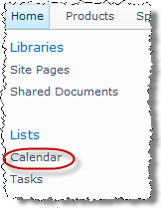

1. Note that the default view in this list is the Calendar view. Switch to the **All Events** view by using the view choices in the drop-down menu found under the heading **Current View:** in the **Calendar** tab’s **Manage Views** group within the **Calendar Tools** contextual tab group in the ribbon.

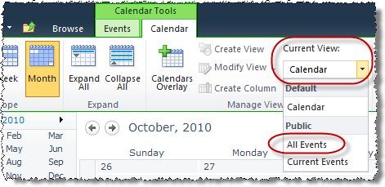

1. Write down in the following space provided the individual event item columns (also known as metadata) Michael Sullivan is authorized to see:  
     
   \_\_\_\_\_\_\_\_\_\_\_\_\_\_\_\_\_\_\_\_\_\_\_\_\_\_\_\_\_\_\_\_\_\_\_\_\_\_\_\_\_\_\_\_\_\_\_\_\_\_\_\_\_\_\_\_\_\_\_\_\_\_\_\_\_\_\_\_\_\_\_\_\_\_\_\_  
     
   \_\_\_\_\_\_\_\_\_\_\_\_\_\_\_\_\_\_\_\_\_\_\_\_\_\_\_\_\_\_\_\_\_\_\_\_\_\_\_\_\_\_\_\_\_\_\_\_\_\_\_\_\_\_\_\_\_\_\_\_\_\_\_\_\_\_\_\_\_\_\_\_\_\_\_\_  
     
   \_\_\_\_\_\_\_\_\_\_\_\_\_\_\_\_\_\_\_\_\_\_\_\_\_\_\_\_\_\_\_\_\_\_\_\_\_\_\_\_\_\_\_\_\_\_\_\_\_\_\_\_\_\_\_\_\_\_\_\_\_\_\_\_\_\_\_\_\_\_\_\_\_\_\_\_
2. Return to the Wingtip Team Site by clicking the **Wingtip Team Site** link in the top navigation bar.
3. From the Wingtip Team Site home page, view the site's Announcements list:
4. Click the **All Site Content** link at the bottom of the Quick Launch bar:

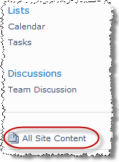

1. Scroll down to the **Lists** heading and click the **Announcements** list:

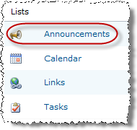

1. Note that the icons in the **Items** tab in the **List Tools** contextual tab group in the ribbon are disabled / grayed out indicating he does not have the necessary authority to add or edit items in the Announcements list.

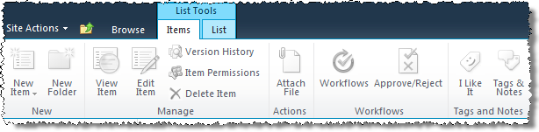

1. Write down in the following space provided the announcement item columns Michael is authorized to see:

\_\_\_\_\_\_\_\_\_\_\_\_\_\_\_\_\_\_\_\_\_\_\_\_\_\_\_\_\_\_\_\_\_\_\_\_\_\_\_\_\_\_\_\_\_\_\_\_\_\_\_\_\_\_\_\_\_\_\_\_\_\_\_\_\_\_\_\_\_\_\_\_\_\_\_\_  
  
\_\_\_\_\_\_\_\_\_\_\_\_\_\_\_\_\_\_\_\_\_\_\_\_\_\_\_\_\_\_\_\_\_\_\_\_\_\_\_\_\_\_\_\_\_\_\_\_\_\_\_\_\_\_\_\_\_\_\_\_\_\_\_\_\_\_\_\_\_\_\_\_\_\_\_\_  
  
\_\_\_\_\_\_\_\_\_\_\_\_\_\_\_\_\_\_\_\_\_\_\_\_\_\_\_\_\_\_\_\_\_\_\_\_\_\_\_\_\_\_\_\_\_\_\_\_\_\_\_\_\_\_\_\_\_\_\_\_\_\_\_\_\_\_\_\_\_\_\_\_\_\_\_\_

1. Return to the Wingtip Team Site by clicking the **Wingtip Team Site** link in the top navigation bar.
2. Login to SharePoint as a different user: Janice Galvin.
3. From the **Welcome Menu** in the top-right corner of the page, select on **Sign in as Different User**.
4. Enter [[AD-DOMAIN]]\janice for a **User Name** & click **OK**. Use the password specified in the *Hands-On Lab Overview* document provided in the student manual.
5. From the Wingtip Team Site home page, view the site's Tasks List:
6. Use the Quick Launch bar to browse to the **Tasks** list of the Wingtip Team Site.
7. Open the new item dialog box by clicking on the **New Item** button in the **New** group in the **Item** tab within the **List Tools** contextual tab group in the ribbon.

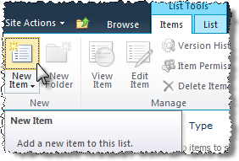

1. Write down in the following space provided the task item columns you can input for new task items (do not fill in any fields):

\_\_\_\_\_\_\_\_\_\_\_\_\_\_\_\_\_\_\_\_\_\_\_\_\_\_\_\_\_\_\_\_\_\_\_\_\_\_\_\_\_\_\_\_\_\_\_\_\_\_\_\_\_\_\_\_\_\_\_\_\_\_\_\_\_\_\_\_\_\_\_\_\_\_\_\_  
  
\_\_\_\_\_\_\_\_\_\_\_\_\_\_\_\_\_\_\_\_\_\_\_\_\_\_\_\_\_\_\_\_\_\_\_\_\_\_\_\_\_\_\_\_\_\_\_\_\_\_\_\_\_\_\_\_\_\_\_\_\_\_\_\_\_\_\_\_\_\_\_\_\_\_\_\_  
  
\_\_\_\_\_\_\_\_\_\_\_\_\_\_\_\_\_\_\_\_\_\_\_\_\_\_\_\_\_\_\_\_\_\_\_\_\_\_\_\_\_\_\_\_\_\_\_\_\_\_\_\_\_\_\_\_\_\_\_\_\_\_\_\_\_\_\_\_\_\_\_\_\_\_\_\_

1. Click **Cancel** to avoid creating a new task item.
2. Return to the Wingtip Team Site by clicking the **Wingtip Team Site** link in the top navigation bar.
3. Login to SharePoint as a different user: Michael Sullivan.
4. From the **Welcome Menu** in the top-right corner of the page, select on **Sign in as Different User**.
5. Enter [[AD-DOMAIN]]\michael for a **User Name** & click **OK**. Use the password specified in the *Hands-On Lab Overview* document provided in the student manual.
6. From the Wingtip Team Site home page, view the site's Links list:
7. Click the **All Site Content** link in the Quick Launch bar.
8. Scroll down to the **Lists** heading and click the **Links** list.
9. Write down in the following space provided the link item columns Michael is authorized to see:

\_\_\_\_\_\_\_\_\_\_\_\_\_\_\_\_\_\_\_\_\_\_\_\_\_\_\_\_\_\_\_\_\_\_\_\_\_\_\_\_\_\_\_\_\_\_\_\_\_\_\_\_\_\_\_\_\_\_\_\_\_\_\_\_\_\_\_\_\_\_\_\_\_\_\_\_  
  
\_\_\_\_\_\_\_\_\_\_\_\_\_\_\_\_\_\_\_\_\_\_\_\_\_\_\_\_\_\_\_\_\_\_\_\_\_\_\_\_\_\_\_\_\_\_\_\_\_\_\_\_\_\_\_\_\_\_\_\_\_\_\_\_\_\_\_\_\_\_\_\_\_\_\_\_  
  
\_\_\_\_\_\_\_\_\_\_\_\_\_\_\_\_\_\_\_\_\_\_\_\_\_\_\_\_\_\_\_\_\_\_\_\_\_\_\_\_\_\_\_\_\_\_\_\_\_\_\_\_\_\_\_\_\_\_\_\_\_\_\_\_\_\_\_\_\_\_\_\_\_\_\_\_

1. Does Michael have the necessary authority to add new links to the Links list?

**Yes\_\_\_ No\_\_\_**

1. Return to the Wingtip Team Site by using the hyperlink in the breadcrumb trail.
2. From the Wingtip Team Site home page, view the Shared Documents document library:
3. Notice the Web Part in the center of the page that exposes the Shared Documents document library.

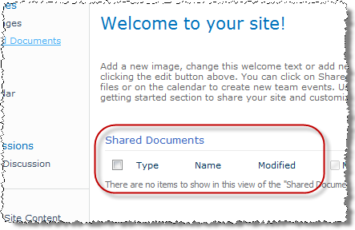

1. Go to the **Shared Documents** document library by clicking on the library title **Shared Documents** within the **Shared Documents Web Part**.
2. Return to the Wingtip Team Site using the top navigation bar.
3. Click the **Shared Documents** link in the Quick Launch bar to revisit the library another way.
4. Return to the Wingtip Team Site using the top navigation bar.
5. Click the **All Site Content** link at the bottom of the Quick Launch bar.
6. Scroll down the **Document Libraries** heading and click the **Shared Documents** link to revisit the library yet another way.
7. Return to the Wingtip Team Site by using the top navigation bar.
8. From the lists viewed in this Exercise, choose the appropriate list for the following scenarios:

|  |  |
| --- | --- |
| **Scenario** | **List** |
| You need to notify the rest of your team that the weekly status meeting on Fridays will be held at 11:00am this coming Friday instead of at the normal meeting time of 9:00am. |  |
| A customer has requested a sales meeting with one of the Wingtip salespeople on your team. You need to alert Sam that you want him to setup the meeting and record the meeting's details in SharePoint. |  |
| A new product outline document has just been made available to your team and you want them all to know about the file and have the chance to examine it. |  |
| You need your team to be aware of a customer visit to occur on next Thursday's date. |  |
| Everyone on your team needs quick access to a vendor website where they can retrieve Material Safety Data Sheets. |  |

1. From additional list templates, choose the appropriate list to request for the following scenarios:

|  |  |
| --- | --- |
| Scenario | List Template |
| You need to keep up with the different assignments each of your team members are completing and identify any downtime. |  |
| You need to record customer complaints and how they are being handled. |  |
| You wish to collect feedback from team members about a new vendor. |  |
| You want your team to be able to get in touch with customer and vendor representatives quickly and easily. |  |
| You wish to provide your team with a format in which they can engage in healthy, casual debate over current projects and issues. |  |

In this exercise you learned about default lists on a SharePoint 2010 Team Site and how to employ them.

## Exercise 2: Manipulating List Items

In this exercise you will populate an existing list with items then manage those items by editing them and eventually deleting them.

1. Login to SharePoint as a different user: **Janice Galvin**.
2. From the **Welcome Menu** in the top-right corner of the page, select on **Sign in as Different User**.
3. Enter [[AD-DOMAIN]]\janice for a **User Name** & click **OK**. Use the password specified in the Hands-On Lab Overview document provided in the student manual.
4. Navigate to the **Products** site by clicking the **Products** link in the top navigation bar if you aren’t already in the Products site.
5. Add a new event to the Calendar:
6. Navigate to the **Calendar** list via a method you prefer that you learned in the previous exercises.
7. Click on the **Calendar** date box of the day that is one week from today (notice that this will change the scope of the Calendar view from Month to Day).

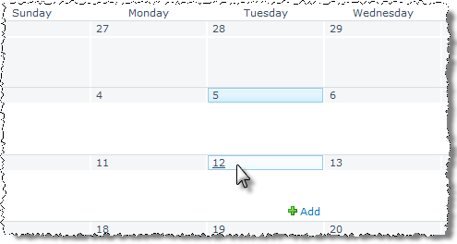

1. Click in the hour box for **4:00pm** and click the **Add** link that appears in the right side of the hour box:



1. In the resulting dialog box, enter the following event:

**Title:** Customer Visits

**Location:** Lobby

**Start Time:** 4:00pm (should already be the value because you clicked the 4:00pm hour box)

**End Time:** 5:00pm (default end time is 30 minutes past start time, or 4:30pm)

**Description:** Open hour for customers to visit our facility. Team members must be available in the lobby to greet customers.

**Category:** Meeting

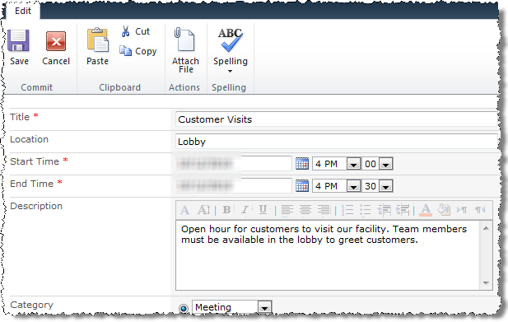

1. Click the **Save** button to create the new event and return to the Calendar view in Day scope focused one week from today. Confirm creation of your 4:00pm event.
2. Return the **Calendar** view to the Month view by clicking the **Month** button in the **Scope** group in the **Calendar Tools » Calendar** tab in the ribbon.

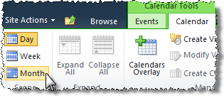

1. Use the Events tab in the ribbon to add a new event:
2. Click the **New Event** button in the **Calendar Tools » Events** tab in the ribbon.
3. In the resulting pop up dialog box, enter the following event:

**Title:** Weekly Status Meeting

**Location:** Conference Room B

**Start Time:** 2:00pm

**End Time:** 3:00pm

**Description:** All team members must attend the weekly status meeting (either in person or via conference call) to report on the status of their ongoing projects.

**Category:** Meeting

**Recurrence:** Yes - Weekly - Once per week on Friday - Start Date = next Friday.

1. Click the **Save** button to create the new event and return to the **Calendar** view in **Month** scope. Confirm creation of your recurring weekly status meeting.

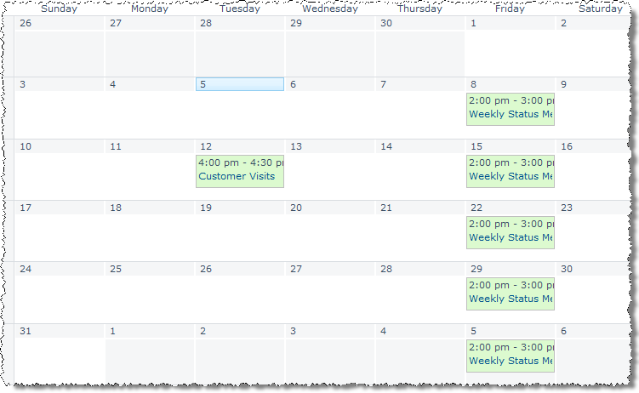

1. Add a new Task to the Tasks list:
2. Navigate to the **Tasks** list via your preferred method:
3. Click the hyperlink to Add new item from the All Tasks view:

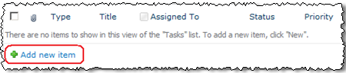

1. In the resulting dialog, enter the following task:

**Title:** Update Status Report Templates

**Predecessors:** <blank>

**Priority:** (2) Normal

**Status:** Not Started

**% Complete:** <blank>

**Assigned To:** Ken Sanchez

**Description:** Please update the document templates for the blank status report form

**Start Date:** Today

**Due Date:** One week from today

**Note:** After typing Ken Sanchez in the Assigned To field, click the check names icon to the right of the text box to resolve the user’s name.

1. Click the **Save** button to create the new task and return to the Task list. Confirm creation of the new task.

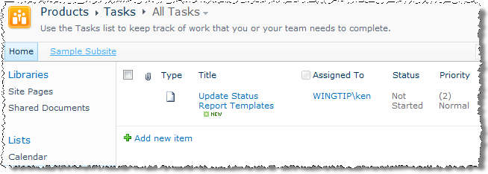

1. Return to the Products site by clicking on the **Products** link in the breadcrumb trail
2. Login to SharePoint as a different user: **Ken Sanchez**.
3. From the **Welcome Menu** in the top-right corner of the page, select on **Sign in as Different User**.
4. Enter [[AD-DOMAIN]]\ken for a **User Name** & click **OK**. Use the password specified in the *Hands-On Lab Overview* document provided in the student manual.
5. Update the task newly assigned to Ken for updating the status report templates:
6. Navigate to the **Tasks** list via your preferred method.
7. Click on the title of the **Update Status Report Templates** item.
8. Click the **Edit Item** button in the **View** tab in the ribbon.
9. Change the **Status** value to **Waiting on Someone Else**.
10. Change the **% Complete** value to **75**.
11. Click the **Save** button to update the task and return to the Tasks list.
12. Switch users by logging out as Ken and in as Janice Galvin:
13. Login to SharePoint as a different user: **Janice Galvin**.
14. From the **Welcome Menu** in the top-right corner of the page, select on **Sign in as Different User**.
15. Enter [[AD-DOMAIN]]\janice for a **User Name** & click **OK**. Use the password specified in the *Hands-On Lab Overview* document provided in the student manual.
16. Delete the Update Status Report Templates task:
17. Hover over the **Update Status Report Templates** task item and click in the selector checkbox to check the box (the **List Tools » Items** tab in the ribbon should immediately appear across the top of the list):

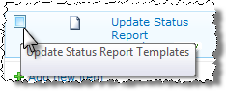

1. Click the **Delete Item** button to delete the checked item from the list:

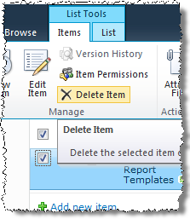

In this exercise you manipulated lists by adding items, editing an item and deleting an item.

## Exercise 3: Selecting a List View

In this exercise you will explore the views that are available on different default lists in the Products Team Site and learn to select the appropriate view for a specific purpose.

1. Navigate to the Products subsite by clicking the **Products** link in the top navigation bar.

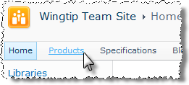

1. View the Products site's Calendar by clicking the **Calendar** link in the Quick Launch bar. Notice the how the ribbon contains different tabs and contextual tabs.

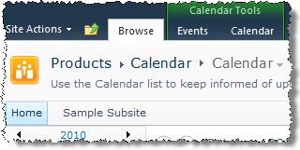

1. Change from the Calendar view to the All Events view via the breadcrumb trail:
2. Hover the mouse cursor over the title of the current view, **Calendar**, in the breadcrumb trail:

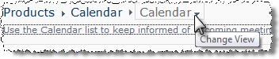

1. Click the down arrow and select the **All Events** view in the drop-down menu to change the current view.
2. Notice the interface differences in the **All Events** view, including the tabs in the ribbon and the absence of the **Calendar Tools** contextual tab group that were visible in the **Calendar** view.

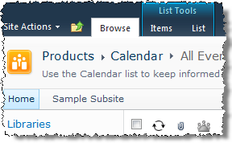

1. Click the **Calendar** hyperlink in the breadcrumb trail and select the **Calendar** view to return to the default view of the list (the Calendar view).
2. Imagine that you need to see only those events that are schedule from today to within the next 2 weeks. All events that happened in the past and those scheduled further out into the future do not need to be viewable for this purpose. To accomplish this, engage the Current Events view from the Calendar ribbon.
3. Switch to the **Current Events** view by using the view choices in the drop-down menu found under the heading **Current View:** in the **Calendar Tools » Calendar** tab in the ribbon.
4. Notice that the view appears similar to the All Events view however the list of event items has been trimmed to only those events coming up in the next couple of weeks with a new **Previous** and **Next** pagination links.
5. Click the **Calendar** hyperlink in the breadcrumb trail to return to the default view of the list (the Calendar view).
6. Return to the Wingtip Team Products Site:
7. Click on **Navigate Up** icon in the page header then choose the **Products** link.
8. View the Products site's Announcements & Links lists using the Lists header link in the Quick Launch bar:
9. Click the **Lists** header's hyperlink in the Quick Launch bar.
10. Click the **Announcements** list's hyperlink.
11. Use the **Current View:** drop down menu in the **List Tools » List** tab in the ribbon and note that there is only one view on a default Announcements list: the All Items view (which you are already on).

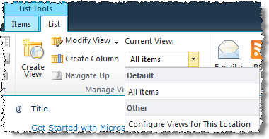

1. Click the **Lists** header's hyperlink in the Quick Launch bar.
2. Click the **Links** list's hyperlink.
3. Use the **Current View:** drop down menu in the List tab within the ribbon and note that there is only one view on a default Links list: the **All Links** view (which you are already on).
4. Click on **Navigate Up** icon in the page header then choose the **Products** link.
5. Visit the Products site's Tasks list using the list's link in the Quick Launch bar.
6. Use a method you have already learned to navigate to the **Tasks** list.
7. Change from the **All Tasks** view to the **My Tasks** view:
8. Hover your mouse cursor over the title of the current view in the breadcrumb trail.
9. Click on the title of the **My Tasks** view in the drop-down menu to change the current view.
10. Notice that not only are the list of items trimmed to only those tasks that have been assigned to the current user but also the amount of metadata exposed about these items (columns) has been trimmed to less detail.
11. Switch to the **Due Today** view either via the breadcrumb trail or **List Tools » List** tab in the ribbon.
12. Notice that all tasks due today even those assigned to individuals other than Michael are now viewable.
13. Imagine that you need to see all tasks regardless of status, completion percentage or due date. However you would like to see the items grouped together according to the team member they have been assigned to. To accomplish this, switch to the **By Assigned To** view.
14. Return to the Wingtip Team Products Site by clicking the **Navigate Up** icon in the page header then choose the **Products** link.

In this exercise you explored the views available on default list templates found on a Team Site and when to employ each view.